ADITYA DEGREE COLLEGES
ANDHRA PRADESH

MID – 1 COMMERCE SYLLABUS
I Semester Syllabus
BOM

DSC 2 A - Business Organization & Management
Unit-I: Introduction: Concepts of Business, Trade , Industry and Commerce – Features of Business -Trade Classification - Aids to Trade – Industry – Classification – Relationship among Trade, Industry and Commerce.
Unit-II: Forms of Business Organizations: Forms of Business Organization: Sole Proprietorship, Joint Hindu Family Firm, Partnership firm, Joint Stock Company, Cooperative Society; Choice of Form of Organization. Government - Business Interface; Public Sector Enterprises (PSEs) - Multinational Corporations (MNCs).
Unit-III: Joint Stock Company: Company Incorporation: Preparation of important Documents for incorporation of Company – Memorandum of Association

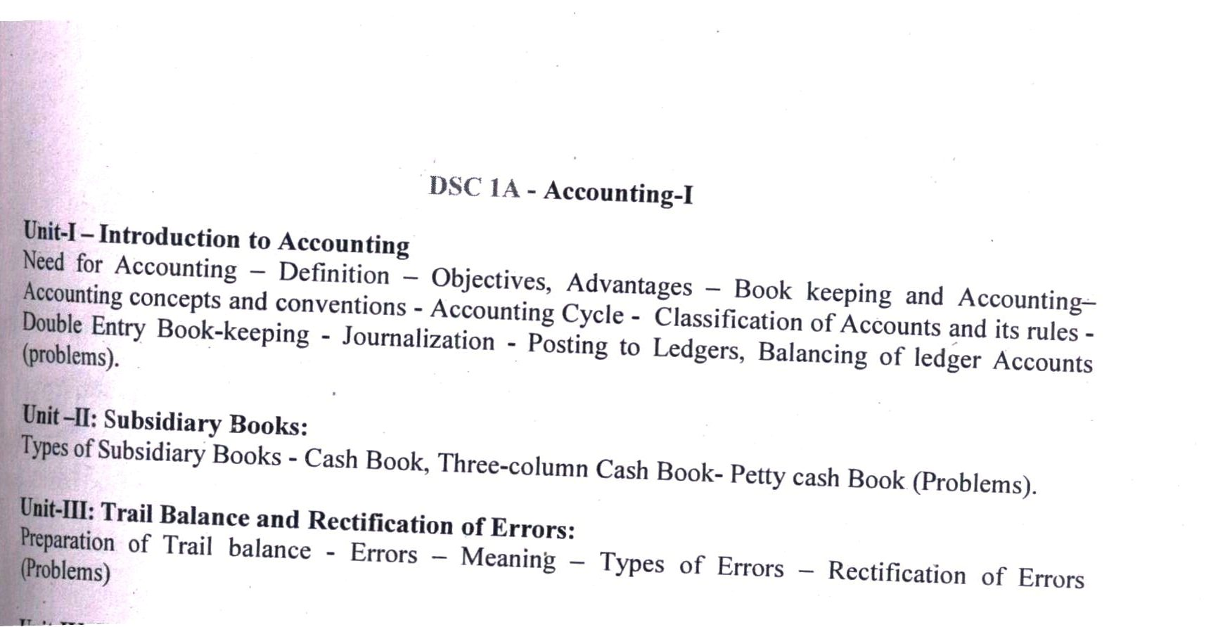

COMPUTER FUNDAMENTALS AND PHOTOSHOP
UNIT-I:
Introduction to computers: Characteristics and limitations of computer, Block diagram of computer,
types of computers, uses of computers, computer generations.Number systems: working with binary, octal, decimal and Hexa decimal numbering system.

UNIT-II:
Input and Output devices: Keyboard and mouse, inputting data in other ways, Pointing Devices,
Handheld Devices, Optical Devices, Audio-Visual Input Devices.Output Devices: Monitors, Projectors,Speakers, Printers, Plotters.
Types of Software: system software, Application software, commercial, open source, domain and free
ware software, Memories: Primary, Secondary and cache memory. Secondary Storage Devices: Magnetic Tapes, Floppy Disks, Hard Disks. Windows basics: Start menu, icons, MSWindows-Desktop, My Computer, My Documents, Pictures, Music, Videos, Recycle Bin, and Task Bar - Control Panel
Unit –III
Introduction to Adobe photoshop: Getting started with photoshop, creating and saving a document in photoshop, page layout and back ground,

III Semester Syllabus

CRA
DSC 1 C - Corporate Accounting
Unit-I:
Accounting for Share Capital - Issue, forfeiture and reissue of forfeited shares- concept & process of book building - Issue of rights and bonus shares - Buyback of shares (preparation of Journal and Ledger).
Unit-II:
Issue and Redemption of Debentures - Employee Stock Options – Accounting Treatment for Convertible and Non-Convertible debentures (preparation of Journal and Ledger).
Unit –III:
Valuation of Goodwill :Need and methods - Normal Profit Method, Super Profits Method – Capitalization Method problems.

BUSINESS STATISTICS

DSC 2C - Business Statistics
Unit 1: Introduction to Statistics:
Definition, importance and limitations of statistics - Collection of data - Schedule and questionnaire – Frequency distribution – Tabulation -Diagrammatic and graphic presentation of data using Computers (Excel).
Unit 2: Measures of Central Tendency:
Characteristics of measures of Central Tendency-Types of Averages – Arithmetic Mean, Geometric Mean, Harmonic Mean, Median, Mode, Deciles, Percentiles, Properties of averages and their applications.
Unit 3: Measures of dispersion and Skewness:
Properties of dispersion – Range - Quartile Deviation –Mean Deviation-Standard Deviation- Coefficient of
Variation

OFFICE AUTOMATION TOOLS
COMMON FOR B.A(CA) and B.Com (CA)

Unit- I:
MS-Excel: features of Ms-Excel, Parts of MS-Excel window, entering and editing data
in worksheet, number formatting in excel, different cell references, how to enter and edit formula
in excel, auto fill and custom fill, printing options.
Unit-II:
Formatting options: Different formatting options, change row height, formulae and
functions, excel names. Functions: Meaning and advantages of functions, different types of
functions available in Excel, financial functions, date and time, engineering, statistical, math and
trig, logical, text, information, look up and reference functions, operators in excel, Database
functions.
Unit-Ill:
Charts: Different types of charts, Parts of chart, chart creation using wizard, chart
operations

V SEMESTER
TAXATION

DSC 2E 5.3 Taxation
Unit-I: Introduction: Objectives - Principles of Taxation - Brief History - Basic Concepts; Capital and Revenue; Basis of Charge - Exempted Incomes - Residential Status – Incidence of Taxation.
Unit-II: Good and Service Tax and its fundamentals
Unit-III: Computation of income under different heads: Income from Salary; Income from House Property; Income from Business/Profession, Charges Deemed Profits to Tax

BANKING & THEORY
DSC 1D - Banking Theory & Practice
Unit-I: Introduction Meaning & Definition of Bank – Functions of Commercial Banks – Kinds of Banks - Central Banking Vs. Commercial Banking.
Unit-II: Banking Systems Unit Banking , Branch Banking, Investment Banking- Innovations in banking – E banking - Online and Offshore Banking , Internet Banking - Anywhere Banking - ATMs - RTGS.
Unit-III: Banking Development Indigenous Banking - Cooperative Banks, Regional Rural banks

COST ACCOUNTING

DSC - 1E 5.2 Cost Accounting
Unit-I:Introduction: Distinguish between Financial Accounting, Cost Accounting and management accounting - Cost Concepts and Classification – Cost Centre and Cost Unit – Preparation of Cost Sheet.
Unit-II: Elements of Cost: Materials: Material control – Selective control, ABC technique – Methods of pricing issues – FIFO, LIFO, Weighted average, Base stock methods, choice of method
(including problems).
Unit-III: Labour and Overheads: Labour: Control of labor costs – time keeping and time booking – Idle time –Methods of remuneration – labour incentives schemes

COMMERCIAL GEOGRAPHY
DSC 3E 5.4 Commercial Geography

Unit –I: The Earth: Internal structure of the Earth – Latitude – Longitude – Realms of the Earth –
Evolution of the Earth – Environmental pollution - Global Warming - Measures to be taken to
protect the Earth.

Unit -II: India – Agriculture: Land Use - Soils - Major crops – Food and Non-food Crops –
Importance of Agriculture – Problems in Agriculture – Agriculture Development.

Unit -III: India – Forestry: Forests – Status of Forests in Andhra Pradesh

DATABASE MANAGEMENT SYSTEM
Unit-I:
Overview of Database Management System: Introduction, Data and Information,
Database, Database Management System, Objectives of DBMS, Evolution of Database Management
Systems, Classification of Database Management System.
Unit-II:
File-Based System, Drawbacks of File-Based System , DBMS Approach, Advantages
of DBMS, Data Models , Components of Database System, Database Architecture.
Unit-III:
Entity–Relationship Model: Introduction, The Building Blocks of an Entity–
Relationship, Classification of Entity Sets , Attribute Classification, Relationship Degree,
Relationship.

WEB TECHNOLOGY
Unit-I: Introduction:
HTML, XML, and WWW, Topologies, Bus, Star, Ring, Hybrid, Tree,
Lan,Wan,Man. HTML: Basic HTML, Document body, Text, Hyper links, Adding more formatting,
Lists, Tables using colors and images. More HTML: Multimedia objects, Frames, Forms towards
interactive, HTML document heading.
Unit-II:
Cascading Style Sheets: Introduction, using Styles, simple examples, your own styles,
properties and values in styles, style sheet, formatting blocks of information, layers.
Unit-III:
Introduction to JavaScript: What is DHTML, JavaScript, basics, variables, string
Manipulations.
BUSINESS LEADERSHIP
Business Leadership
Unit-I: Introductory: Leadership - Traits, Skills and Styles- Leadership Development - Qualities of a Good Leader.
Unit-II: Decision-Making and Leadership: Leadership for Sustainability - Power, Influence, Impact - Leadership Practices

